Principles of the motorcycle (Control)

Physical Model:

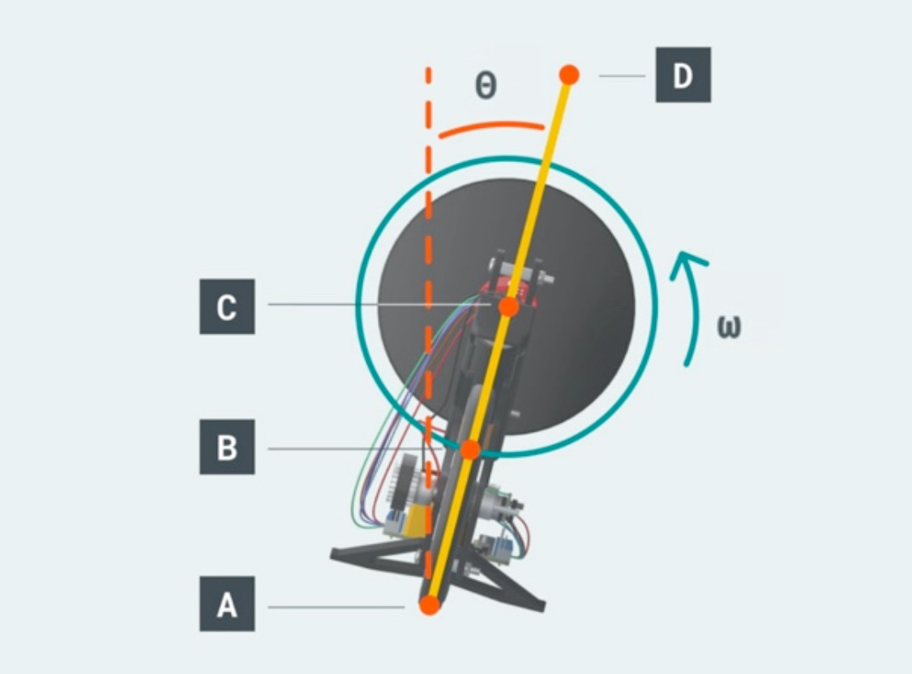

平衡摩托⻋的问题可以被认为是控制倒摆的问题。

The problem of balancing motorcycles can be considered a problem of controlling the inverted pendulum.

我们将摩托⻋建模为由两个关键部件组成的倒⽴摆：1. 通过具有⼀定⾃由度的旋转接头与地⾯相连的钟摆杆。2. 通过另⼀个具有⼀定⾃由度的旋转接头连接到钟摆杆的惯性轮。

We model the motorcycle as an inverted pendulum composed of two key components:

1. A pendulum rod connected to the ground through a rotary joint with a certain degree of freedom.

2. The inertia wheel connected to the pendulum rod through another rotary joint with a certain degree of freedom.

图中A是摆杆与地⾯之间旋转接头的旋转轴。 $l_{AD}$ 是摆杆的⻓度，即摩托⻋框架的⻓度。B是摆杆的质⼼。C是摆杆与惯性轮之间转轴的旋转轴。

In the figure, A is the rotation axis of the rotary joint between the pendulum rod and the ground. Is the length of the pendulum rod, and $l_{AD}$ is the length of the motorcycle frame. B is the quality of the pendulum. C is the rotation axis of the rotation axis between the pendulum rod and the inertia wheel.

我们设置变量：1. 摆杆倾斜⻆度 $θ$，角速度 $\dot{θ},角加速度\ddot{θ}$。当钟摆完全直⽴时等于0度，当钟摆顺时针倾斜时等于正，当钟摆逆时针倾斜时等于负。

1. 惯性轮的转速 $ω$ 和加速度 $\dot{ω}$。

We set the variables:

1. The rotational displacement of the inertia wheel $θ$, angular velocity $\dot{θ}$, and angular acceleration $\ddot{θ}$. When the pendulum is completely straight, it is equal to 0 degrees, when the pendulum is tilted clockwise, it is equal to positive, and when the pendulum is tilted counterclockwise, it is equal to negative.

2. Rotational speed $ω$ and acceleration $\dot{ω}$ of the inertia wheel.

**Model establishment:**

1) First, we analyze torques which are acting on the system.

Torque due to gravity force applied to the pendulum rod:

$$τ_{gr}=m_{r}gl_{AB}\sin{θ}$$

Torque due to gravity force applied to the inertia wheel:

$$τ_{gω}=m_{ω}gl_{AC}\sin{θ}$$

Torques created by the inertia wheel motor:

2) Then we write down equations for moments of inertia of the key components.

Moment of inertia of the inertia wheel about point C:

$$I_{ω}^{C}=0.5m_{ω}R^{2}$$

By applying the parallel axis theorem, we get moment of inertia of the inertia wheel about point A:

$$I_{ω}^{A}=I_{ω}^{C}+m_{ω}l_{AC}^{2}=0.5m_{ω}R^{2}+m_{ω}l_{AC}^{2}=m_{ω}(0.5R^{2}+l_{AC}^{2})$$

Moment of inertia of the pendulum rod around its center

of mass B:

$$I_{r}^{B}=\frac{1}{12}m_{r}(3r^{2}+l_{AD}^{2})$$

By applying the parallel axis theorem, we get moment of inertia of the pendulum rod about point A:

$$I_{r}^{A}=I_{r}^{B}+m_{r}l_{AB}^{2}=\frac{1}{12}m_{r}(3r^{2}+l_{AD}^{2})+m_{r}l_{AB}^{2}$$

1. Next, we write the equations of motion.

Since torque and moment of inertia value are additive:

$$τ_{gr}+τ_{gω}+τ_{m}=(I_{ω}^{A}+I_{r}^{A})\ddot{θ}$$

Which is:

$$m_{r}gl_{AB}\sin{θ}+m_{ω}gl_{AC}\sin{θ}+τ_{m}=[(0.5R^{2}+l_{AC}^{2})+\frac{1}{12}m_{r}(3r^{2}+l_{AD}^{2})+m_{r}l_{AB}^{2}]\ddot{θ}$$

Rotation of the inertia wheel is described by the following equation of motion:

$$τ_{m}=I_{ω}^{C}(\dot{ω}+\ddot{θ})$$

$$τ_{m}=0.5m_{ω}R^{2}(\dot{ω}+\ddot{θ})$$

1. Our next step is bringing the above equations of motion to state-space format. We will firstly define a state vector:

$$x\left(t\right)=\left(\begin{matrix}θ \\ \dot{θ} \\ ω\end{matrix}\right)$$

Finally, we derive the state space expression:

$$\dot{x}\left(t\right)=Ax\left(t\right)+Bu\left(t\right)$$

$=[\begin{matrix}0 & 1 & 0 \\ \frac{g(m_{r}l_{AB}+m_{ω}l_{AC})}{(0.5R^{2}+l_{AC}^{2})+\frac{1}{12}m_{r}(3r^{2}+l_{AD}^{2})+m_{r}l_{AB}^{2}} & 0 & 0 \\ −\frac{g(m_{r}l_{AB}+m_{ω}l_{AC})}{(0.5R^{2}+l_{AC}^{2})+\frac{1}{12}m_{r}(3r^{2}+l_{AD}^{2})+m_{r}l_{AB}^{2}} & 0 & 0\end{matrix}$] $\left(\begin{matrix}θ \\ \dot{θ} \\ ω\end{matrix}\right)+[\begin{matrix}0 \\ −\frac{1}{(0.5R^{2}+l_{AC}^{2})+\frac{1}{12}m_{r}(3r^{2}+l_{AD}^{2})+m_{r}l_{AB}^{2}} \\ \frac{1}{0.5m_{ω}R^{2}}+\frac{1}{(0.5R^{2}+l_{AC}^{2})+\frac{1}{12}m_{r}(3r^{2}+l_{AD}^{2})+m_{r}l_{AB}^{2}}\end{matrix}$] $τ$

Therefore,

$A=[\begin{matrix}0 & 1 & 0 \\ \frac{g(m_{r}l_{AB}+m_{ω}l_{AC})}{(0.5R^{2}+l_{AC}^{2})+\frac{1}{12}m_{r}(3r^{2}+l_{AD}^{2})+m_{r}l_{AB}^{2}} & 0 & 0 \\ −\frac{g(m_{r}l_{AB}+m_{ω}l_{AC})}{(0.5R^{2}+l_{AC}^{2})+\frac{1}{12}m_{r}(3r^{2}+l_{AD}^{2})+m_{r}l_{AB}^{2}} & 0 & 0\end{matrix}$], $B=[\begin{matrix}0 \\ −\frac{1}{(0.5R^{2}+l_{AC}^{2})+\frac{1}{12}m_{r}(3r^{2}+l_{AD}^{2})+m_{r}l_{AB}^{2}} \\ \frac{1}{0.5m_{ω}R^{2}}+\frac{1}{(0.5R^{2}+l_{AC}^{2})+\frac{1}{12}m_{r}(3r^{2}+l_{AD}^{2})+m_{r}l_{AB}^{2}}\end{matrix}$]

Our next step is implementing the above equation in software, to allow simulating the

behavior of this dynamical system and designing a feedback controller.

Controller in Simulink:

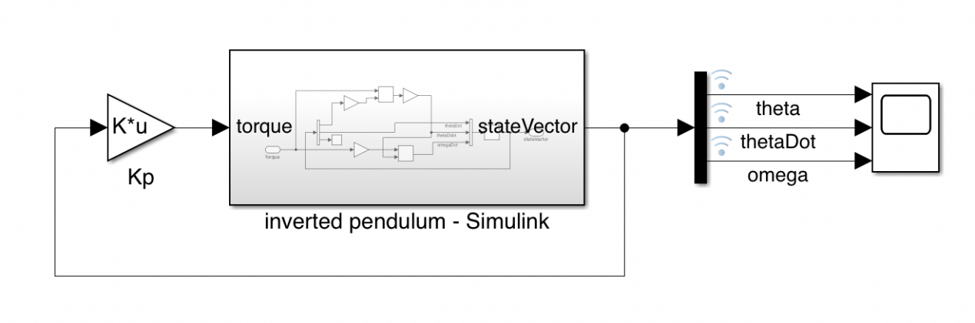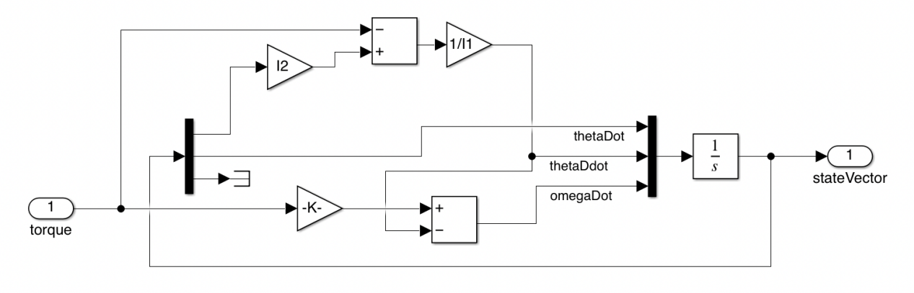

Model parameters:

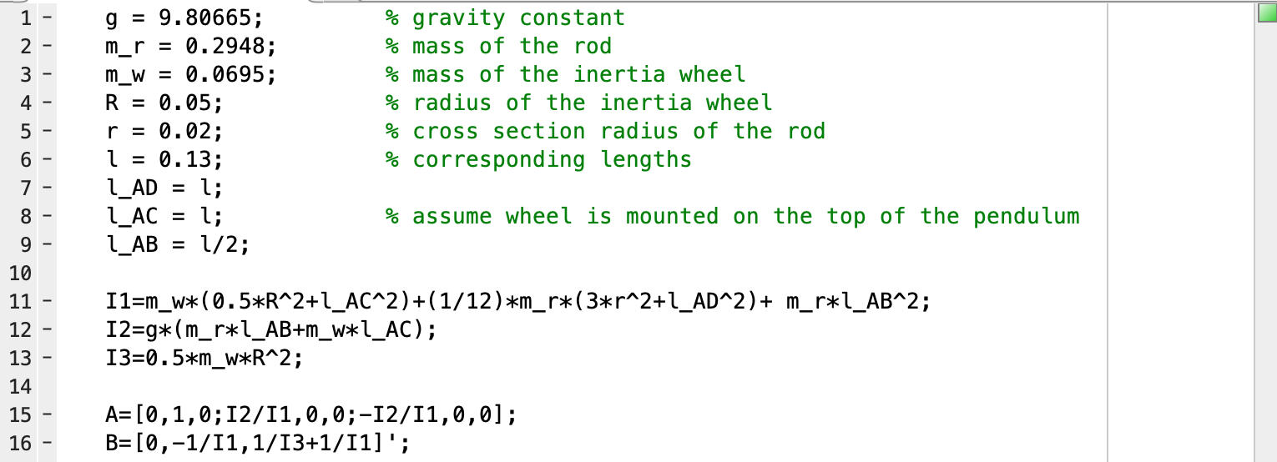

The result:

